**++++ DAY 4 +++++**

**Heads or Tails**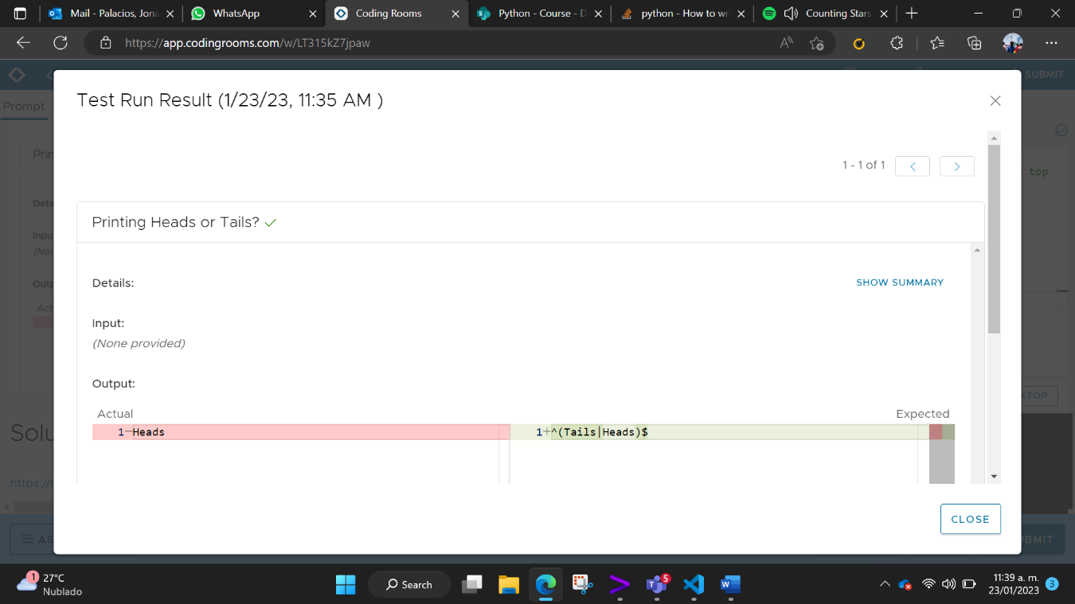

**

**Treasure Map**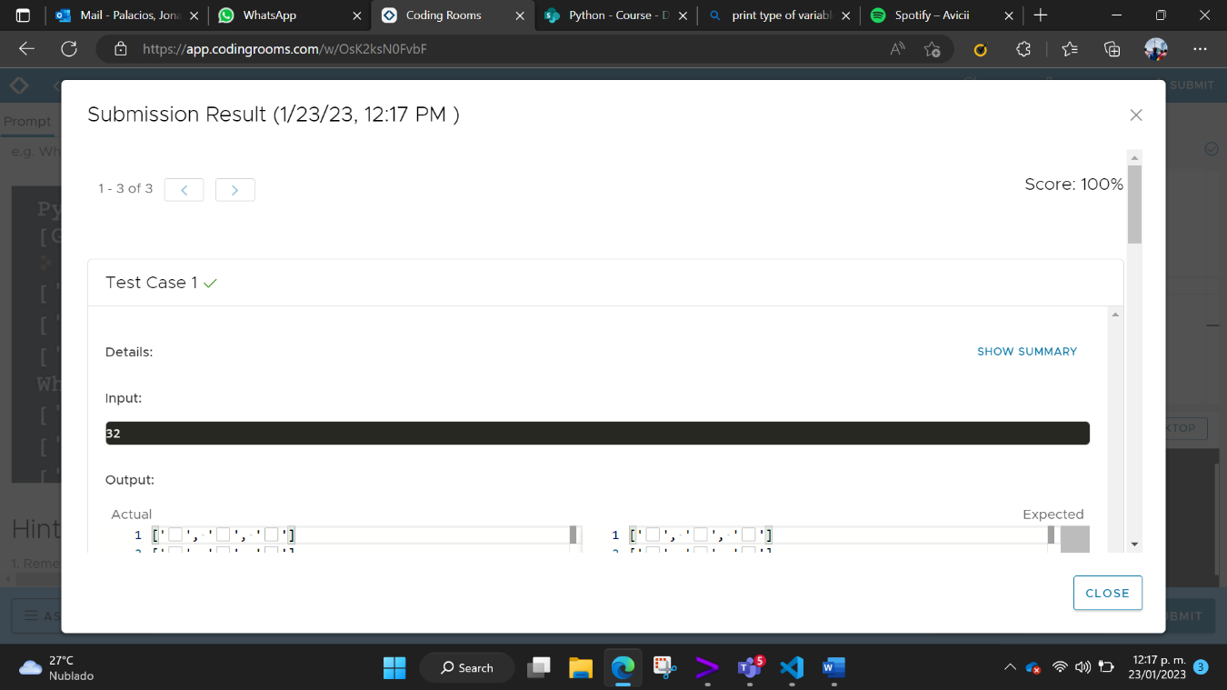

**Rock, Paper, Scissors**

